

# Common Etiologies Associated with Deafblindness

## Table of Contents

* CHARGE Syndrome
* Usher Syndrome
* Down Syndrome
* [Neurofibromatosis](#_Neurofibromatosis_(NF))
* Congenital Rubella Syndrome

* [Cytomegalovirus (CMV)](#_Cytomegalovirus_(CMV))
* Pre-Maturity
* Head Injury
* Infection
* Stroke
* Age Related

There are many reasons why someone may have a combined vision and hearing loss. In many cases, the cause is unknown. Currently in the U.S., the greatest single cause of deafblindness is complications from premature birth.

The causes of deafblindness can be categorized in a variety of ways. For the purposes of this collection of the most common etiologies, the following categories are included:

* Genetic disorders
* Prenatal or congenital complications
* Adventitious conditions

This learning module includes a brief description of only a few of the most common etiologies of deafblindness. The National Consortium on Deaf-Blindness hosts a website that has links to hundreds of resources on specific etiologies at [www.nationaldb.org](http://www.hkonlinecourses.org/Webcourses/Courses/DeafBlindness/www.nationaldb.org).



## Genetic Disorders

CHARGE syndrome and Usher syndrome are the most associated genetic conditions associated with deafblindness. While the prevalence of Down syndrome is higher than CHARGE or Usher combined, not all people with Down syndrome experience a combined vision and hearing loss. There are approximately 70 additional genetic conditions that are associated with combined vision and hearing loss.

### CHARGE Syndrome



CHARGE syndrome is a rare genetic disorder that manifests in a series of birth defects that can include vision and hearing loss. It occurs in approximately 1 out of every 9,000 to 10,000 births. People are typically diagnosed with CHARGE based on the presence of medical features of the syndrome. There is a genetic test to identify the gene associated with the syndrome, but the test is not always accurate as 2/3 of people with CHARGE receive a false negative result. Children born with CHARGE syndrome are affected differently. Many experience extensive medical and physical difficulties while others are more mildly impacted. Over the past decade, CHARGE syndrome has been identified as the leading single syndrome associated with deafblindness in school age children. CHARGE is an acronym representing the clinical features that were historically used to identify children. Those diagnostics have changed over time, but the acronym CHARGE remains. There are several clinical and diagnostic features of CHARGE including:

#### **Primary Features**

* **Coloboma of the eye**– A cleft or hole in one of the structures of the eye that may be present in one or both eyes. This may cause vision loss.
* **Choanal Atresia or stenosis**– bony growth in the nose that causes a narrow or blocked passageway.
* **Cranial Nerve Abnormality**- Swallowing problems, facial palsy.
* **Ear anomalies**- Outer ears have a distinctive look including no ear lobes, floppy, typically short and wide. The middle ear may have malformed bones causing a conductive hearing loss. The inner ear may have atypical semicircular canals (causing balance problems) and a malformed cochlea.

#### **Other Features**

* Heart Defects
* Genital abnormalities
* Growth deficiency
* Cleft lip/palate
* TE fistula (an esophageal abnormality)

### Usher Syndrome



Usher syndrome is the most common genetic (inherited) cause of deafblindness. Recent studies estimate that between 8 and 10% of all individuals who are congenitally deaf or hard of hearing have Usher syndrome. There are three main types of Usher syndrome. All individuals with Usher will have hearing loss and a visual condition called retinitis pigmentosa (RP).

Retinitis pigmentosa is a progressive visual condition. The first symptom may be difficulty seeing at night (night blindness) or in poorly lit or dark environments such as hallways, movie theaters or in any outdoor venue at dusk or during the evening when lighting is poor. The individual with RP is often unaware that they have this condition until their vision loss has progressed significantly. As children or young adults, they may be labeled “clumsy” or “accident prone,” since, due to their night blindness, they bump into people and things in darkened environments. Along with night blindness, RP also causes a loss of peripheral, or side, vision. Whereas individuals with “typical” visual fields can see to their left and right – approximately 180 degrees – individuals with RP gradually lose their side vision. At the later stages of vision loss, their visual fields are such that it is like looking at the world through a tunnel – thus the term “tunnel vision.” This impacts their ability to see people and objects to the far left and right, which may cause them to appear to others as disinterested, absent-minded or careless. The slow and progressive nature of the loss of peripheral vision often causes individuals with RP to be unaware of this loss until their visual fields are quite restricted. They may quite naturally and intuitively adapt to this loss of peripheral vision by deliberately scanning their environment before proceeding.

Along with RP, each type of Usher syndrome has an accompanying hearing loss. Those with Usher I are born profoundly deaf and may experience balance problems. Prior to the availability of cochlear implants, many children with Usher I attended schools for the deaf and eventually became part of the Deaf community. American Sign Language was, for many, their primary language. As night blindness and the loss of peripheral vision slowly progressed, their ability to receive signed information was seriously impacted.

Individuals with Usher II are born hard of hearing with RP. As children, they may use hearing aids and lip-reading to assist with oral/aural communication. As their vision loss progresses, they may have trouble with lip-reading in darkened environments. Some individuals perceive this as an additional loss of hearing when it is actually the effect of the progressive loss of vision. Usher II does not have balance problems associated with it.

Usher III is quite rare, although there are a few cases diagnosed in the U.S. Hearing loss manifests in the mid-teens or early 20s. This hearing loss is progressive. RP is usually diagnosed in the mid-teens. Progressive balance problems are associated with type III.

### 

### Down Syndrome

{Image: A man with glasses is smiling and looking very happy.  He has short brown hair and is wearing a collared shirt. He has features of a person with down syndrome}.



Down syndrome is the most common genetic condition in the United States. One in every 691 babies in the U.S. is born with Down syndrome and there are an estimated 400,000 Americans who have Down syndrome.

Down syndrome is associated with a variety of physical, intellectual and health issues including distinctive facial features, heart defects and learning and behavior challenges.

Children with Down syndrome are often born with a combined vision and hearing loss. It is estimated approximately 60-70% of children with Down syndrome have vision impairments. Eye conditions associated with Down syndrome include nystagmus (involuntary eye movement), strabismus (crossed eyes), farsightedness, nearsightedness, congenital cataracts, keratoconus (the cornea becomes cone shaped over time) and conditions like blepharitis (inflammation of the eyelid) and conjunctivitis. All of these conditions can be treated medically, and with education modifications and low vision adaptations can be extremely helpful.

In addition, it is estimated 75% of children with Down syndrome have hearing loss. Most often the loss is a conductive hearing loss where sound is unable to move through the outer ear into the inner ear due to a blockage most often caused by otitis media (middle ear infection). The effects of persistent or recurrent middle ear infections are noted in hearing loss, speech delays and comprehension. There is also the possibility of sensorineural hearing loss in Down syndrome due to damage to the sensitive hair cells in the cochlea or the auditory nerve. This hearing loss is permanent and cannot be treated.

### 

### Neurofibromatosis (NF)

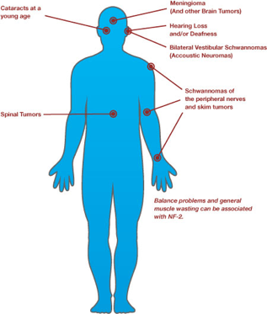

Neurofibromatosis is a genetic disorder that causes (typically) benign tumors to form on nerve tissue anywhere in the body.

Neurofibromatosis affects each person differently depending on where the tumors grow and compress nerves, blood vessels, organs, and other body tissue. NF can range from extremely severe causing heart, hearing, and vision problems to relatively mild and hardly noticeable.

Treatment for NF is often focused on tumor management. In some cases, surgery or chemotherapy is used to remove or shrink tumors that are causing health problems.

NF has been classified into three distinct types: NF1, NF2 and Schwannomata's.

NF2 is closely linked to hearing loss and in some cases, vision loss. In NF2, benign tumors grow on the eighth nerve that carries sound and balance information to the brain. This can cause progressive hearing loss, balance problems and tinnitus (ringing in the ears). Tumors can also grow on the optic nerve causing vision loss. Hearing and vision in people with neurofibromatosis can fluctuate based on management of the affecting tumors.

## Prenatal, Perinatal, and Congenital Complications

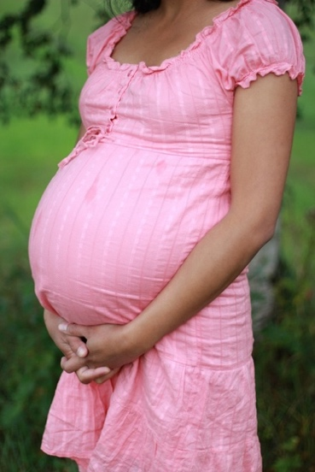

Prenatal, perinatal, and congenital complications are a result of problems that occur during pregnancy. Some of these complications are already present when a woman becomes pregnant or can arise during pregnancy or during the birth. Some of these conditions result from factors that can’t be controlled. But in some cases, such as drug use or congenital rubella syndrome, there are precautions that can be taken to decrease the risk of pregnancy complications.

There are thousands of complications that can occur before, during or immediately after birth that can impact vision and hearing. We include only a few of the most commonly seen conditions resulting in a combined vision and hearing loss.

### Congenital Rubella Syndrome

Congenital rubella syndrome (CRS) is caused when a mother is infected by the rubella virus and passes it to a developing fetus. The severity of CRS can relate to when the mother was infected by the rubella virus. Children of mothers who contract rubella early in pregnancy typically have more severe cases of CRS.

In the mid 1960s, there was a world-wide epidemic of rubella. It is estimated that there were 20,000 cases of CRS in the U.S. because of that outbreak. Many of the services for individuals who are DeafBlind that still exist today developed as a response to this epidemic.

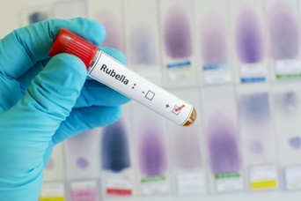

As vaccinations began to control the virus in the late 1960s, the incidence of CRS decreased significantly. However, there are still children born each year with CRS. Some professionals fear that these numbers may increase over time as parents choose not to immunize their children due to fear or autism or other perceived complications relating to vaccines.

The symptoms of CRS have been categorized into early stage and late symptoms or delayed onset. Some of the early symptoms of CRS can include hearing loss, vision loss, congenital heart defects, neurological issues, and developmental delays. Some later emerging symptoms can include diabetes, underactive thyroid, growth hormone deficiency, glaucoma and increase or decrease of seizures. Not all older individuals with CRS develop these complications.

Hearing loss is the most common complication of CRS. Hearing loss can range from mild to severe. Vision loss is another complication of CRS and can emerge as a variety of visual conditions including optic atrophy, cataracts, microphthalmia (smaller than normal eyes), pigmentary retinopathy or nystagmus.

### Cytomegalovirus (CMV)

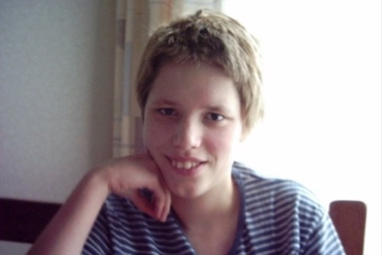

Cytomegalovirus (CMV) is a common virus that is related to chickenpox, herpes simplex and mononucleosis. It is transmitted through body fluids. Most healthy people don’t even realize they have the virus. It can become a problem during pregnancy if a mother passes the active virus to the developing fetus or newborn baby. Transmission usually occurs during the first trimester but can happen at any time. When a baby is born with the CMV infection it is referred to as congenital CMV.

According to the Centers for Disease Control and Prevention, about 30,000 babies are born with congenital CMV each year. The large majority of those babies do not experience any long-term problems as a result. However, about 1 in 750 children born in the U.S. develop problems as a result of the infection. This equates to about 5,000 children each year experiencing permanent health and wellness issues caused by CMV infection.

Some babies who have been infected with the virus have symptoms that are present at birth including:

* Jaundice
* Skin rash
* Small size at birth (or low birth weight)
* Enlarged spleen
* Enlarged and poorly functioning liver
* Pneumonia
* Seizures

Other babies are born with no symptoms but can develop complications later on. The most common late emerging symptom of congenital CMV is sensorineural hearing loss. Hearing loss can be mild to profound and may be progressive. A series of vision problems can also be present or emerge later on including retinitis, optic atrophy, anophthalmia (no eyeball), cataracts and coloboma.

Other complications related to congenital CMV may include intellectual and motor disabilities, cerebral palsy, and seizures.

### Medications, Drug Use and Fetal Alcohol Syndrome

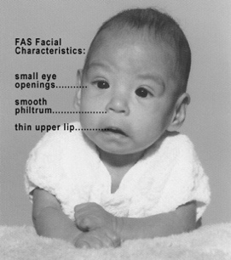

Teratogens including prescription medication, illegal drugs and alcohol can adversely affect a developing fetus and cause a variety of disabilities including vision and hearing loss. The degree of hearing and vision loss and the presence of additional complications varies depending on the type and dosage of the substance and the gestational age of exposure.

Fetal alcohol syndrome (FAS) can result when an expectant mother consumes alcohol during pregnancy. Complications of FAS include microcephaly, intellectual and motor disability, pre- and post-natal growth deficiency. Hearing loss resulting from FAS can be either conductive or sensorineural in nature. Vision loss typically occurs as a result of optic nerve hypoplasia and myopia.

### Intrauterine Complications and Complications at Birth

Complications such as intrauterine stroke and asphyxia (loss of oxygen) can occur during pregnancy or birth. Both can cause hearing and vision loss along with several other serious complications depending on the severity of brain damage. Complications and long-term effects are described below in the section on Stroke and Asphyxia.

### Premature Birth

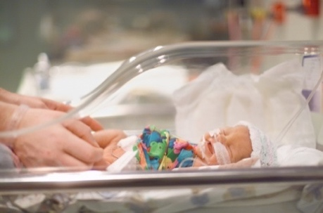

According to the most recent census of DeafBlind children ages 0-21 conducted by the National Consortium of Deaf-Blindness, prematurity is the most prevalent cause of deaf-blindness in the United States.

Most problems and complications associated with prematurity result from organs and body systems not being fully developed. The severity of the complications is most likely associated with the gestational age of the fetus at birth. The lungs, nervous system, kidneys, intestinal system, and heart are some of the organs and systems that can be affected. Metabolic and nervous system issues are also common. Vision loss and hearing loss are seen in people who are born prematurely.

The most common visual condition associated with premature birth is retinopathy of prematurity (ROP) (see section on ROP in Eye Conditions). Glaucoma can also occur along with ROP. Other eye conditions related to prematurity include cataracts of prematurity, optic atrophy, and refractive errors.

Hearing loss can also occur as a result of premature birth. There can be several causes including effects from other impacts of prematurity such as hypoxia and metabolic imbalances. There can also be hemorrhaging in the inner ear due to weak blood vessels that causes damage to the hearing mechanism. Most hearing loss due to prematurity is sensorineural in nature.

## Adventitious Conditions

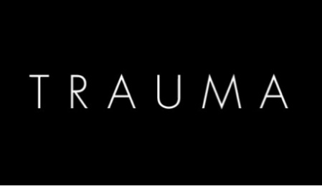

There are a wide variety of traumatic events, diseases and physical conditions that can impact vision and hearing over the course of one’s life. The impact that these conditions have on hearing and vision depends on the type and severity. Next, we will explore events and conditions that can impact vision and hearing.

### Head Injury

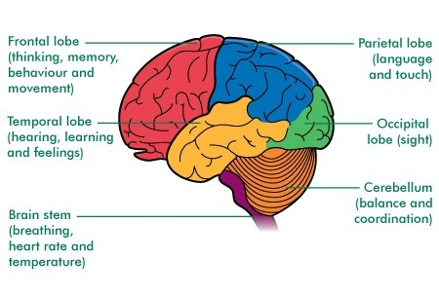

Injury to the head can result in a wide range of mild to severe problems depending on the area of the brain that is impacted and the severity of the trauma. Head injury typically occurs when the brain hits against the sides of the skull potentially causing damage to the brain tissue and the nerves. Swelling and bleeding in the brain can also occur. Trauma to the area of the brain responsible for the motor aspects of the senses and interpreting visual and auditory information can result in vision and hearing loss. The degree of loss depends on the severity of damage and the ability of one’s brain to recover.

There are a wide range of vision issues associated with brain injury including impaired muscle or nerves leading to double vision, strabismus (eyes looking in both directions) or the inability to use one of the eyes, perceptual disorders, tracking problems and central and peripheral blindness or vision loss. If the occipital lobe of the brain is injured, a person may experience cortical visual impairment (CVI). CVI is a vision impairment caused by damage to the posterior visual pathways or the occipital lobes of the brain. With many people who have CVI, the visual system in the eye is intact, however, the brain is not able to receive and interpret the visual information causing the person to function as someone blind or with low vision.

Hearing loss as a result of head injury can be conductive or sensorineural. Conductive loss is typically related to damage to the bones in the middle and inner ear. Sensorineural hearing loss due to head injury is typically related to damage to the auditory nerve or the parts of the brain associated with interpreting auditory signals. Central auditory processing disorder can occur when the part of the brain responsible for auditory processing is damaged and the auditory messages being sent are not able to be received or interpreted.

Head injury may also directly impact the eyes or ears and can result in bone, muscle, nerve or tissue damage. Hearing and vision loss related to direct trauma to the eyes and ears vary significantly depending on the location and extent of the damage.

### Infections

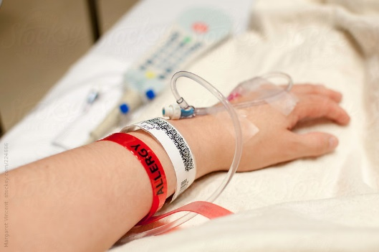

Meningitis and encephalitis are the two most common infections that can result in a combined hearing and vision loss.

Meningitis is the term used when the membranes surrounding the brain become inflamed because of a bacterial or viral infection. Encephalitis refers to inflammation of the brain occurring as a result of a virus or a bug bite.

As a result of the swelling and pressure brought on by both conditions, brain damage can occur resulting in vision and hearing loss. This is most commonly seen in meningitis. This damage can cause a variety of conditions including seizures, motor disabilities and intellectual disabilities. Vision loss related to meningitis can be permanent or temporary depending on the damage to the optic nerve. Meningitis can also result in sensorineural hearing loss.

### Cerebral Vascular Incident (CVA) or Stroke

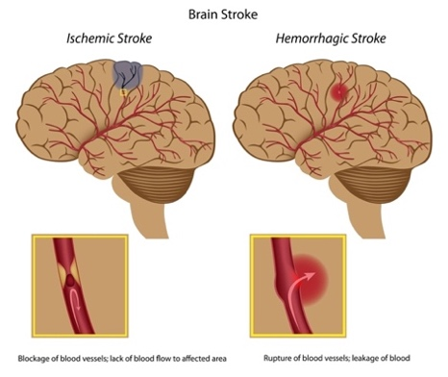

A CVA, commonly referred to as a “stroke” occurs when the blood supply to the brain is interrupted or reduced causing a lack of oxygen and nutrients to the brain. This causes brain tissue to die within minutes resulting in a variety of conditions that may be permanent or temporary depending on the location, severity, and type of stroke.

Some common effects of stroke are motor impairment (difficulty walking or moving arms), swallowing, speech or language and vision. The effects of stroke on vision and hearing depends on the location and the degree of damage to the brain.

When a stroke impacts the right side of the brain, it is more likely that visual functions will be impacted including visual field loss, blurry or double vision and sensitivity to light. There can also be problems with depth perception and movement of objects and people. Sometimes a stroke can cause entire parts of the visual field to be absent. For some people, vision therapy may help a person to regain some or all their vision. For others, vision loss is permanent.

Stroke is more likely to cause vision loss than hearing loss, although hearing loss can occur as a result of stroke. The impact on a person’s hearing following a stroke depends on the location and severity of the stroke. For example, a stroke that causes damage in the temporal lobe of the brain may result in a mild hearing loss if the damage is only in one temporal lobe. Although rare, if both temporal lobes are impacted, the result can be complete deafness.

### Asphyxia

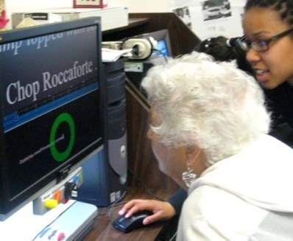

Asphyxia occurs when the body is deprived of oxygen leading to a variety of conditions depending on the length and severity of the oxygen deprivation. Asphyxia can be the result of an accident traumatic birth, drugs or drowning and can result in severe disabilities including cerebral palsy, seizures, and intellectual disabilities. Vision and hearing can be impacted depending on the extent of the brain damage and is most likely to occur when asphyxia occurs during pregnancy or birth.

## Age Related Deafblindness

Combined vision and hearing loss is one of the most common age-related conditions affecting senior citizens (age 55 and over). Seniors with a combined vision and hearing loss comprise the greatest number of people who are DeafBlind in the U.S. Hearing and vision loss later in life has a severe impact on a person's social, physical and mental health and can profoundly impact their daily functioning and independence.

One of the challenges of diagnosing and treating age-related dual sensory loss is that oftentimes seniors do not self-identify as having a vision or hearing loss and try to compensate for their loss in other ways.

Vision conditions most commonly associated with aging include age-related macular degeneration, cataracts, glaucoma, and diabetic retinopathy.

There are no specific hearing conditions that are associated with aging. Most age-related hearing loss is due to the degeneration of hair cells in the inner ear. These hair cells that carry auditory impulses to the cochlea and off to the brain, die off over the course of one’s life and do not grow back. Other factors that can impact hearing over a lifetime are exposure to noises, hereditary factors, and some medications. Diabetes and smoking have been linked to an increased risk of hearing loss.

## Summary

Understanding the reason why someone is DeafBlind can be an essential component in providing the best support to that person. Knowing the age of onset of deafblindness, the progressive nature of the condition and any additional disabilities the person may be dealing with can help professionals support a person who is DeafBlind to prepare for current and future possibilities and identify the most appropriate resources. When professionals have clear and accurate information about a specific etiology, they can become a resource to the consumer, family members, employers, and the community at large.