

# Interpreting Audiograms: A Resource for Providers, Family Members and DeafBlind Individuals

## What is an Audiogram?

An audiogram is a visual representation of a person’s hearing ability. It charts the softest sounds a person can hear at various frequencies, measured in decibels (dB) and Hertz (Hz). Audiograms are used by audiologists to diagnose hearing loss and recommend appropriate interventions, such as hearing aids or assistive devices.

## How does an Audiogram Work?

An audiogram has two types of tests:

* **Air Conduction**: This test evaluates sound traveling through the entire ear system—outer, middle, and inner ear—using headphones or ear inserts.
* **Bone Conduction**: This test bypasses the outer and middle ear to assess the inner ear's function. A bone conduction oscillator on a headband delivers sound directly to the inner ear, helping to identify the type and location of hearing loss.

## Types of Hearing Loss

Refer to the HKNC resource, *“*[*Types of Hearing Loss*](https://www.helenkeller.org/resources/types-of-hearing-loss/)*,”* for more details on the following categories:

* **Sensorineural Hearing Loss**
* **Conductive Hearing Loss**
* **Mixed Hearing Loss**
* **Central Auditory Processing Disorder (CAPD)**

## Key Audiogram Basics

### Axes of the Audiogram:

* **X-axis (Horizontal)**: Frequencies (Pitch), measured in Hertz (Hz).
  + *Low pitch* sounds (e.g., bass drum) are on the left.
  + *High pitch* sounds (e.g., bird chirp) are on the right.
* **Y-axis (Vertical)**: Hearing levels in Decibels (dB), measure loudness.
  + Top **(0-20 dB)** = Normal hearing
  + Bottom **(71+ dB)** = Severe: profound hearing loss

**Sample Audiogram (X and Y Axis)**

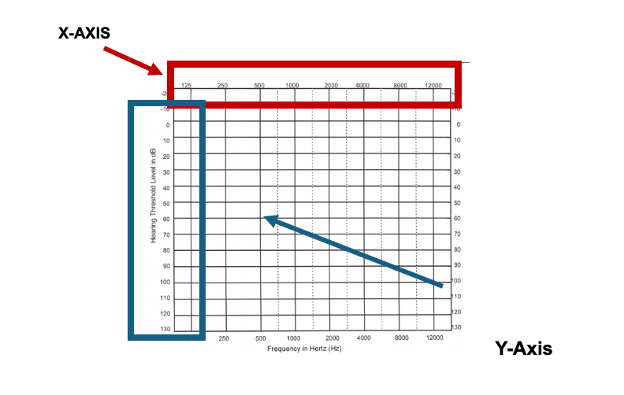

### Symbols and Terms on the Audiogram

* **O (Red):** Right ear results.
* **X (Blue):** Left ear results.
* **Brackets or triangles** may indicate results when hearing aids are used.
* **Masking:** involves introducing noise into the non-test ear during hearing assessments to prevent it from detecting sounds meant for the test ear. This technique ensures that each ear's hearing ability is measured independently, leading to more accurate identification of hearing thresholds and types of hearing loss.

|  |  |  |
| --- | --- | --- |
| **Key** | **Right**  **RED** | **LEFT**  **Blue** |
| A/C | ⭕️ | **X** |
| A/C no response | Red circle with a downward-pointing arrow through its center | **X** |
| A/C masking |  |  |
| A/C masking no response | A red triangle with a downward-pointing arrow through its center | Blue square with a downward-pointing arrow through its center. |
| BC | < | > |
| B/C no response | [ | ] |
| B/C masking no response | Red bracket with a downward-pointing arrow through its center | Blue bracket with a downward-pointing arrow through its center |

## Degrees of Hearing Loss

Here’s what the hearing levels mean:

|  |  |  |
| --- | --- | --- |
| **Decibel Level (dB)** | **Hearing Range** | **What It Means** |
| 0-20 dB | Normal Hearing | Can hear most soft sounds clearly. |
| 21-40 dB | Mild Hearing Loss | Trouble hearing soft sounds or distant speech. |
| 41-55 dB | Moderate Hearing Loss | Difficulty hearing conversational speech. |
| 56-70 dB | Moderately Severe Hearing Loss | Cannot hear normal conversation without aids. |
| 71-90 dB | Severe Hearing Loss | Hears only loud sounds (e.g., shouting). |
| 91+ dB | Profound Hearing Loss | Hears very little; often relies on visual/tactile cues. |

|  | |
| --- | --- |
|  |  | |  |

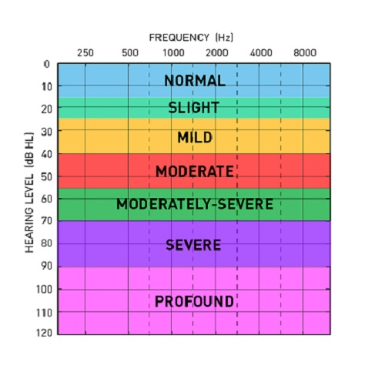

## Questions to Ask When Reviewing an Audiogram:

* What is the degree of hearing loss (mild, moderate, severe, profound)?
* Which ear has better hearing?
* Do they hear better at high or low pitches?
* What accommodations or devices do they use to access communication?
* Is the individual’s hearing loss stable or progressive?
* How does the individual’s vision status impact their strategies to access hearing?

**Sample Audiogram:** Sensorineural High Frequency Hearing Loss (Typical in older Adults)

An Audiogram red circle blue X at normal rates through 2000 Hz but at 4,000 Hz drops to 50 db Loss and then up to 30dB loss at 8,000 Hz


* Both ears have same thresholds for bone conduction. When air and bone conductions thresholds are within 15 dB of each other – Sensorineural hearing loss
* Normal hearing thresholds bilaterally through 2,000 Hz
* Dropping to a moderate loss at 4,000 Hz
* Rising to a mild loss at 8,000 Hz

**Sample 2: Conductive Hearing Loss**

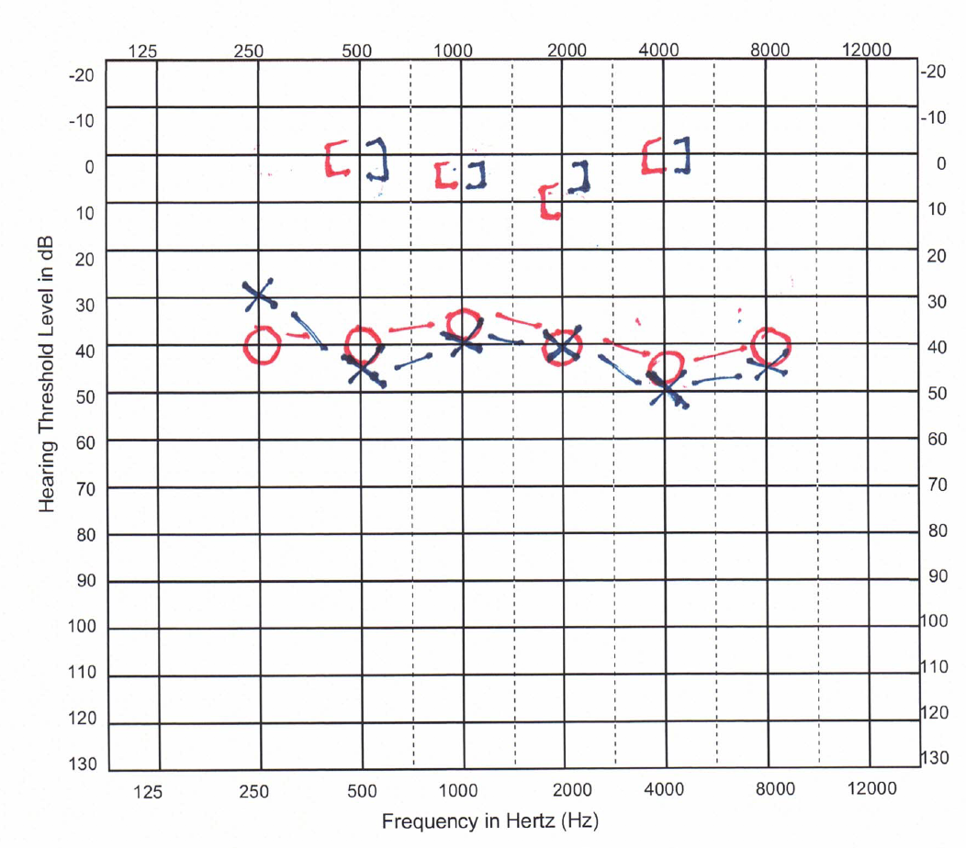

**Note:** the air conduction thresholds are between 30 dB and 50 dB, and the bone conduction thresholds are between 0 dB and 10 dB. This shows a conductive hearing loss.

## Speech Banana:

The speech banana is a region on an audiogram that represents the frequencies where most speech sounds occur, typically ranging from 125 Hz to 8000 Hz. Providers can use the speech banana to better understand which speech sounds and other common sounds an individual can access based on their hearing ability. By comparing the individual's audiogram to the speech banana, providers can identify which sounds fall within their hearing range.

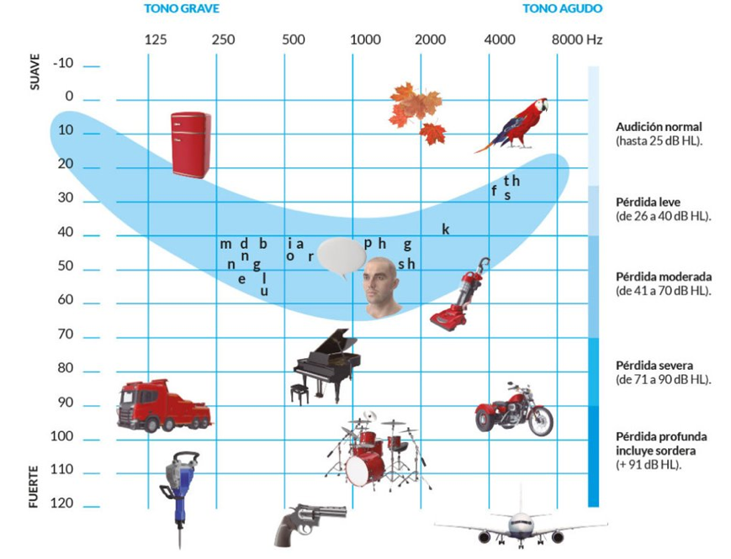

For a more detailed explanation of where speech and environmental sounds fall within different frequencies, please refer to this link: [Speech Banana Audiogram](https://learn.helenkeller.org/mod/page/view.php?id=2696)

## Conclusion:

Understanding audiograms and types of hearing loss is an essential step in supporting individuals with combined hearing and vision loss. To learn more, please refer to the HKNC course [*Audiological Considerations for People with Combined Hearing and Vision Loss*.](https://www.helenkeller.org/courses/audiological-considerations-for-people-with-dual-sensory-loss/) For personalized guidance, reach out to a local audiologist who can provide assessments and recommendations tailored to individual needs.