

Tips for Working with a Sign Language Interpreter When Communicating with a DeafBlind individual


An interpreter’s role is to facilitate communication between people. A certified Interpreter is obligated to abide by a code of professional conduct dictated by the Registry of Interpreters for the Deaf that requires adherence to strict standards of confidentiality, neutrality, professionalism and respect for consumers. It is important to note that interpreters can facilitate sign to spoken language or vice versa but can also be used for text interpreting, voice-over and to provide visual information through touch, text or spoken language.
An interpreter interpreting from English to ASL and vice versa is not simply replacing an English word for a signed representation of that word. American Sign Language has its own grammatical rules, sentence structure and cultural nuance. Therefore, the interpreter must thoroughly understand the point of what is being said before being able to interpret it.

When to Hire an Interpreter
In many situations, an interpreter is essential to facilitate clear communication. It is always best to ask the consumer if they require an interpreter and if so, what is their preferred communication mode (i.e., tactile sign, close vision sign, text or voice over). | 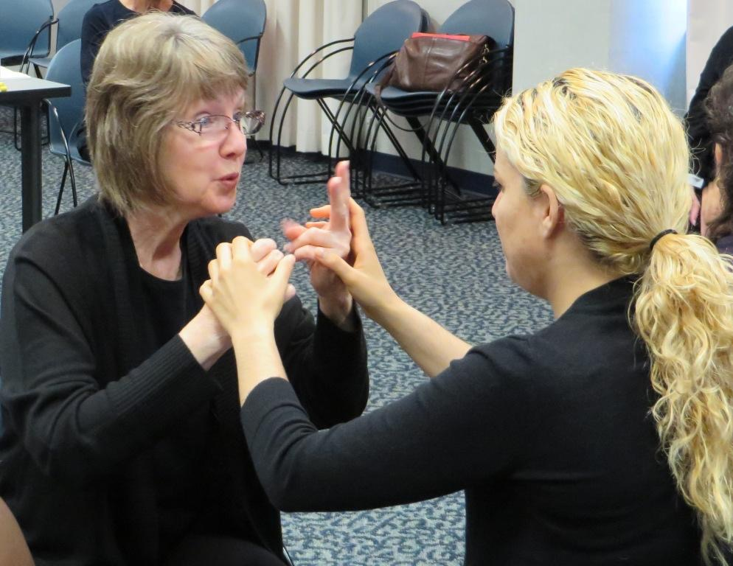

When working with individuals who are DeafBlind, it is best to specifically request an interpreter who is skilled in working with this population. An experienced DeafBlind interpreter should understand modifications for vision loss, and how to incorporate visual and environmental information.
Many people who are DeafBlind have local interpreters that they know and are comfortable with. Registry of Interpreters for the Deaf (www.rid.org) is another resource to help find a local agency. It is important to identify the specific communication needs of the consumer. It may also be helpful to request an interpreter who has interpreted previously in a similar setting so that they are familiar with the terminology.
It is important to note that two interpreters may be necessary depending on the length of the meeting and the method of communication being used. Tactile sign language can be quite strenuous and therefore interpreters typically rotate every 20 minutes.

Interpreter Etiquette  Important considerations when working with a sign language interpreter: | 
When hiring an interpreter, it is important to provide them with information about the meeting such as the purpose of the meeting and any relevant prior history related to the meeting. Any papers or materials related to the meeting should be shared with the interpreter ahead of time (i.e., medical terms and explanations)
- Make sure you allow enough time for the meeting. Using an interpreter typically takes longer and using an interpreter with someone who is DeafBlind will take even longer.
- It is important to be flexible and allow time for set up of a room prior to a meeting. If the consumer has some usable vision it is important for the speaker to sit next to the interpreter so the consumer may look back and forth from speaker to interpreter, additional accommodations may be necessary such as finding a dark solid background for the interpreter to sit in front of, avoiding window glare, or setting up a table to rest on while receiving sign tactually.
- Allow time at the beginning of your meeting to pre-conference with the interpreter if needed. This can be used to review the purpose of the meeting and share any pertinent information or terminology that will be used. Also allow some time for the interpreter and consumer to become familiar with their communication styles and determine specific supports that will be needed.
- Remember to always speak directly to the DeafBlind consumer. Never say “tell him/her…”
- Use plain English. Avoid jargon when possible. Remember, the interpreter needs to understand the point to be able to interpret it.
- At times the interpreter may need to ask for repetition or clarification.
- Remember to take pauses so that the interpreter has time to catch up. This does not mean speaking at an exaggerated slow pace but rather taking natural pauses. Additional time will be needed, as often the interpreter will be providing visual and environmental information as well.
- Remember the interpreter will interpret all visual and auditory information. Do not ask the interpreter not to interpret something. Refrain from asking the interpreter for his/her opinion. If you are not sure the consumer understands, ask the consumer directly.
- Be aware that there may need to be significant modifications to the environment based on the individual’s vision. This may mean moving to a bigger room to allow distance between interpreter and individual, closing blinds to reduce glare or having a color backdrop available to increase contrast.
- Some consumers prefer an armchair or to sit at the corner of a table so they can rest their arms on the table when receiving sign tactually. It is not uncommon for a tactile sign user to request a pillow to rest their arm on when receiving sign language.
- Often tactile signers as well as individuals relying on their residual vision may require frequent breaks due to the strain placed on their eyes and arms.
- Spell Out Technical Words. It is helpful to have technical terms or jargon relating to a particular discipline or concept to be spelled or written out, either on the chalkboard, an overhead projector, a class handout, or with some other visual aid.
- Remember a DeafBlind individual often cannot participate in an activity (i.e., taking blood and access communication at the same time. Make sure to explain what you are going to do prior to doing it.
- Repeat or Paraphrase Questions and Responses. When questions are asked, be sure to repeat or paraphrase questions before a response is given. Likewise, responses should also be repeated or paraphrased.

