

Respectful Interactions

Tips for Interacting with an Individual who is DeafBlind
Understanding basic information about accessibility and supporting the full participation of people who are DeafBlind is important for anyone who is working with, living with and/or supporting a person with a combined hearing and vision loss. Knowing how to provide visual and environmental information is critical in ensuring that a person who is DeafBlind has access to the information they need to make decisions and interact with their environment on their own terms. It is particularly important for those working with individuals who are DeafBlind to understand that their role is to provide access and information, not to make decisions for the person. Feeling comfortable with the social norms relating to approaching, communicating and interacting with people who are DeafBlind ensures that interactions are respectful, enjoyable and that the person who is DeafBlind can participate fully and equally.

- Approaching: When approaching a DeafBlind person, let them know you are there by placing your hand on their shoulder. Maintain contact with the person until they visually or tactually locate you.



Video Demonstration: Approaching a DeafBlind Person
Transcript
- Always identify yourself immediately. Never say “guess who” to a person who is DeafBlind. This is considered rude. There are several ways you can identify yourself including saying your name, signing your name or providing your name signal. Check in with the individual to determine what would work for them.
- Provide Visual Information: Provide information about the individual’s surroundings such as who is in the room, what people are doing, the layout of the room. Always Inform the DeafBlind person when you or others are entering or leaving the room. Check with the individual to determine the method they prefer you use to provide this information. Visual information can be provided via:
  - Sign language (visual or tactile)
  - Speech
  - Touch (Haptics and/or ProTactile)
See video below for a demonstration of how touch can be used to provide very pertinent information without needing to interrupt a person while signing or partaking in any activity.

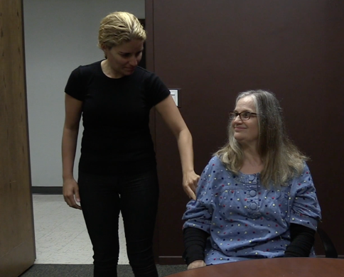
Using Touch to Provide Information about Exiting or Entering a space
Transcript

          - Learn more about Haptics: Haptics Video Series
          - Learn more about ProTactile at ProTactile.org

- Hand under Hand Technique: When guiding a person’s hand to an object or person place your hand under their hand. They will place their palm on the top of your hand and follow your movements. This way the DeafBlind individual is in control. They can disconnect when and if they choose. Never grab the person’s hand and pull.

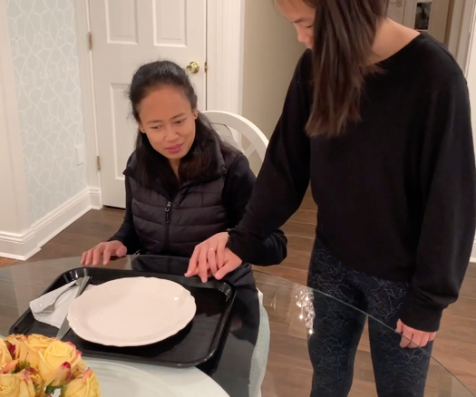

Hand Under Hand Approach: Do’s and Don’ts
Transcript

Hand Under Hand Approach: Orienting to the Dinner Table
Transcript

- Provide accessible feedback when communicating with an individual who is DeafBlind. A great deal of our communication is expressed via facial expressions and body movement. If the individual does not have access to this “feedback” it can feel like they are “talking to a wall”. Make sure to provide information such as I’m nodding, I’m laughing, or I’m shocked to the individual via speech, sign or touch (Haptics or PT). Check in with the individual to see how they would like to receive this information.

- Inclusion: Always offer to include the DeafBlind individual in your conversation. Never say this is not important or I will tell you later. Allow the individual to determine if they would like to be included or not, do not make that decision for them.

- Allow for extra time: Be aware of “DeafBlind Time.” As many DeafBlind people report, “everything takes longer when you are DeafBlind.” Be aware of this and make sure you have additional time allotted in your schedule. DeafBlind person will need to get situated before being able to engage in a conversation or activity. This is true for people who communicate in visual or tactile sign language, speech or text. They may need to:
        - Remove their coat or jacket
        - Put down their bag
        - Be guided to their seat
        - be oriented to their environment
        - set their dog guide up or put away their cane

Many DeafBlind people need their hands to communicate. Be aware of this. They may not be able participate in an activity such as eating or putting on their coat and access communication at the same time. Make sure to provide information ahead of time or wait for the individual to complete the activity they are participating in and then attempt to communicate with them. Allow for extra time for this. The individual will let you know when they are ready. But pressing the individual to hurry or starting the conversation or activity before the individual is ready is not appropriate.

